AMANULLAH (ITDB) F2017065056

**HOTEL TRANSYLVANIA**

ADVANTAGES:

* Efficient
* Secure
* Easy to use

ER DIAGRAM:

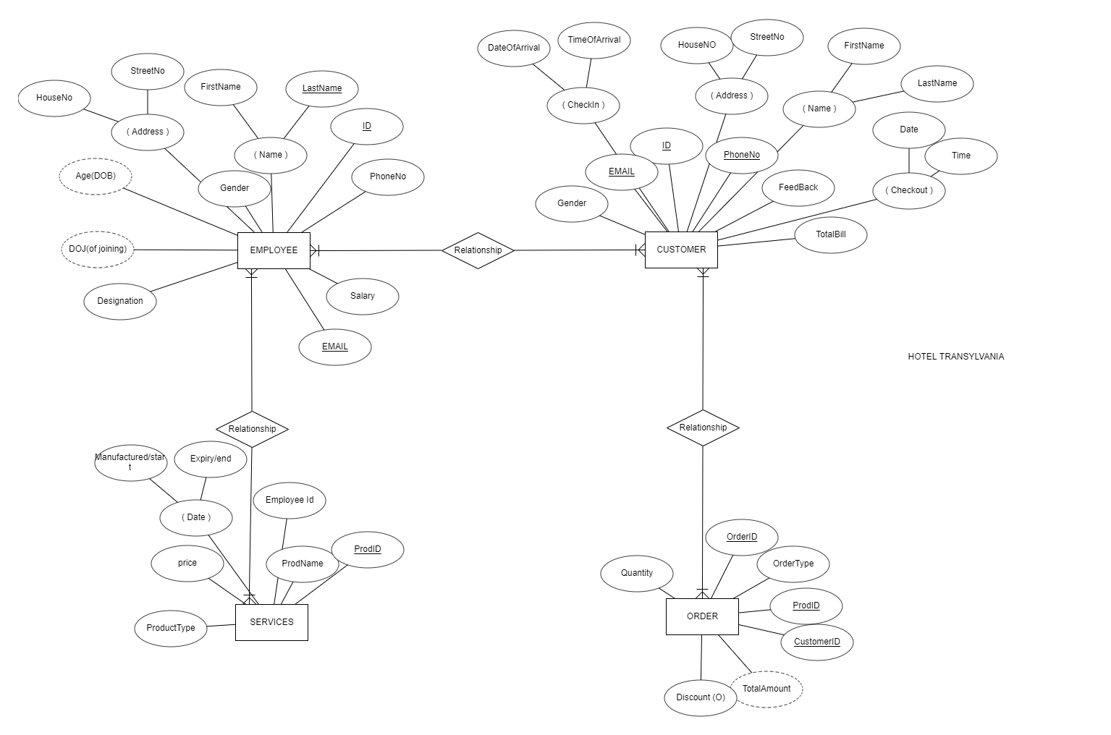

RELATIONAL SCHEMA

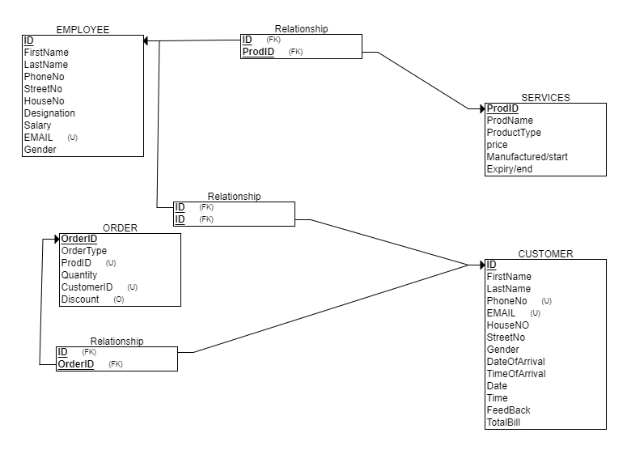

ENTITIES:

* EMPLOYEE
* SERVICES
* ORDER
* CUSTOMER

ATTRIBUTES:

CUSTOMER

* **varchar** Name(30)

* firstName

* lastName

* **integer** ID (20)
* **varchar** Gender(1)
* **varchar** EMAIL(30)
* **integer** PhoneNo(11)
* **varchar** FeedBack(50)
* **integer** BillOrder
* **integer** Checkout
* **varchar** Address(50)
* **Date** CheckIn

EMPLOYEE

* **integer** ID(20)
* **varchar** Designation(10)
* **integer** DOJ(of joining)(20)
* **integer** Age(DOB)(4)
* **varchar** Address(50)
* **varchar** Name(30)

**varchar** firstName

**varchar** lastName

* **Varchar** PhoneNo(11)
* **integer** Salary(9)
* **varchar** EMAIL(30)

SERVICES

* **integer** ProdID(10)
* **varchar** ProdName(20)
* **varchar** ProductType(30)
* **integer** price(4)
* **Date** Expiry
* **Date MenuDate**
* **QOH**

ORDER

* **integer** OrderID(30)
* **varchar** OrderType(30)
* **integer** ProdID(10)
* **integer** CustomerID(20)
* **integer** TotalAmount(7)
* **integer** Discount(5)
* **integer** Quantity

Foreign Keys:

* Customer ID
* Employee id
* ProdID

Primary Keys:

* Employee id
* CustomerID
* ProdID
* OrderID